

**CS/CE 4337 - Assignment#3 Due Date: 10/20/19, 11:59 pm**

1. Write three functions in C++ : one that declares a large array statistically, one that declares the same large array on the stack, and one that creates the same large array from the heap . Call each of the subprograms a large number of times (at least 100000) and output the time required by each .

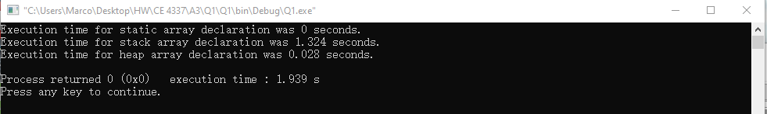

1. Write test programs in Java to determine the scope of a variable declared in a for statement. Specifically, the code must determine whether such a variable is visible after the body of the for statement

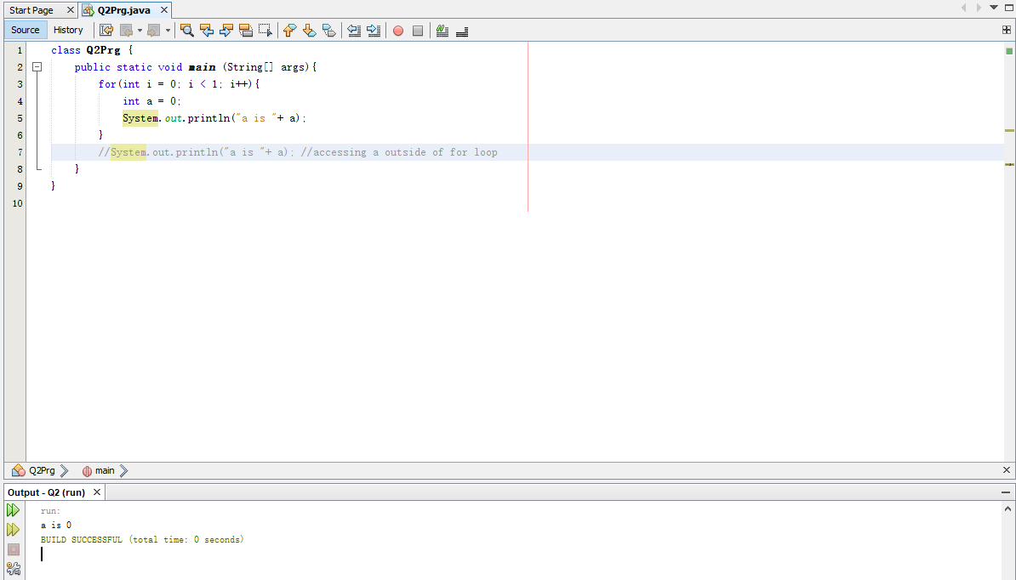

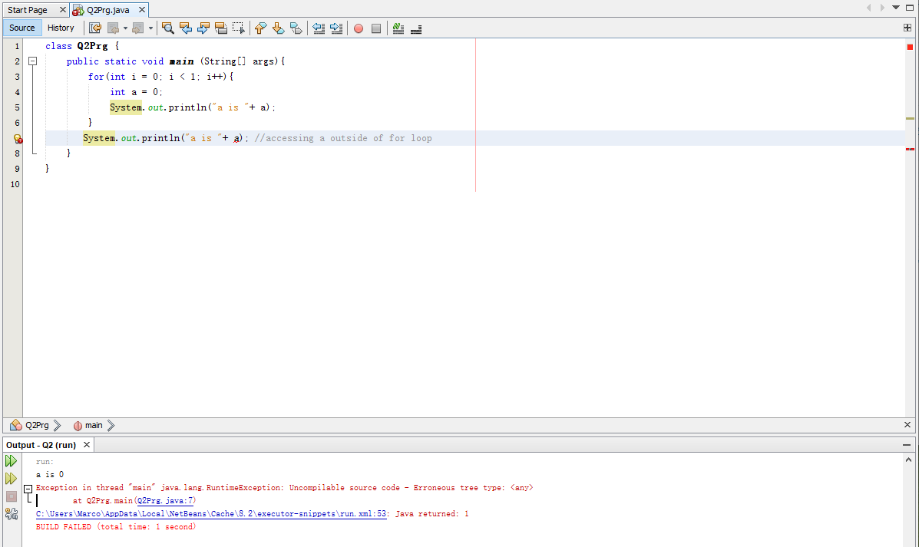

1. Write a Python program that has subprograms nested three deep and in which each nested subprogram references local variables, variables defined in all of its enclosing subprograms, and global variables.

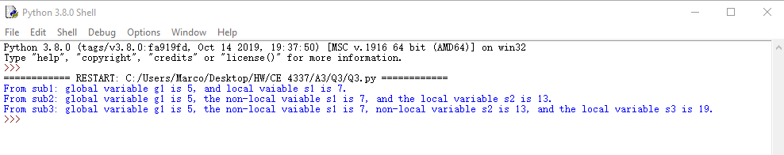

1. Design a set of simple test programs to determine the type compatibility rules of a java compiler to which you have access. Write a report (7-15 lines)

In java, there is implicit and explicit type compatibility rules. Values are converted implicitly to the value of next level during multiplication and division of an integer and a float or double value. Their result will always be float or double. Explicit conversion happens when casting a value to another type. The order of widening in explicit conversion is byte, short, int, long, float, and double. As a variable gets widen, its information will still retain. On the other hand, when narrowing a variable, the insignificant part of the variable will be truncated during the process. The narrowing order is the exact opposite of the widening order. A char variable can be converted to double, float, long, and int. During the conversion, only the ASCII code of the char variable will retain. It is not possible to convert from numerical variables to char variables, char variables or numerical variables to Boolean variables, or from Boolean variables to char variables or numerical variables.

Implicit:

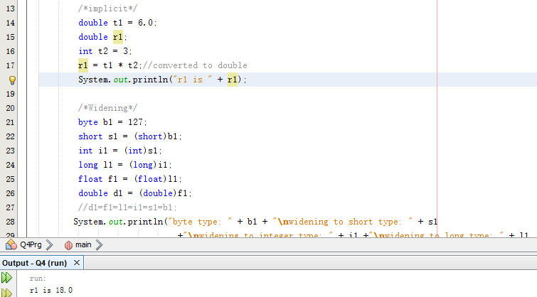

Widening and narrowing:

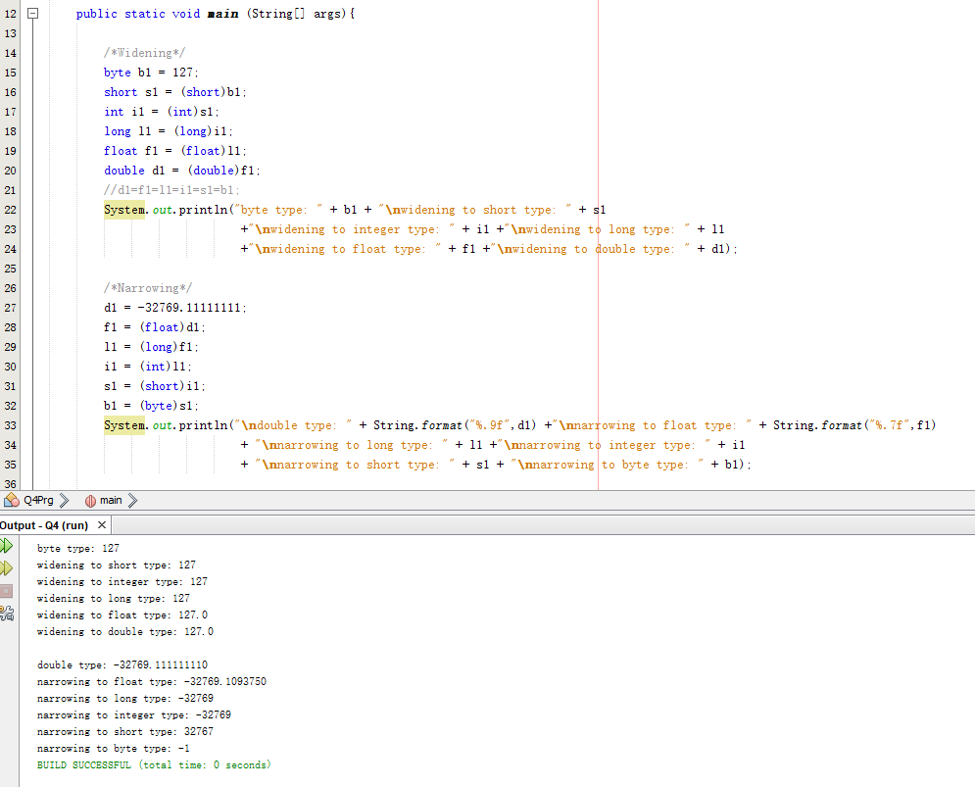

Char to num:

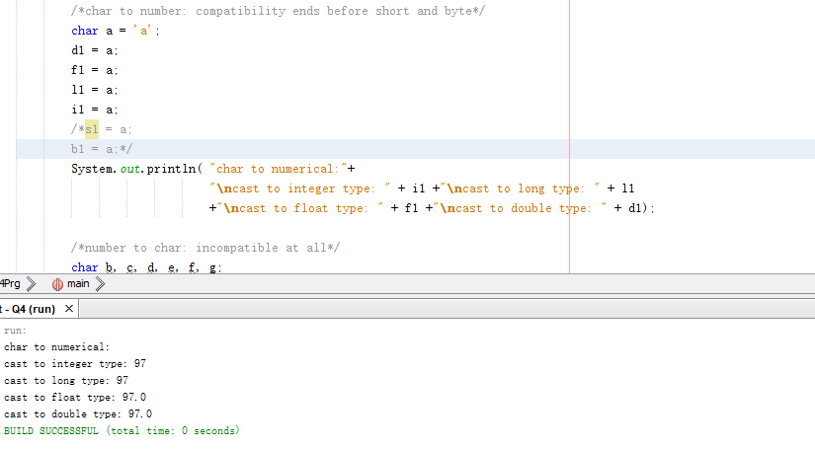

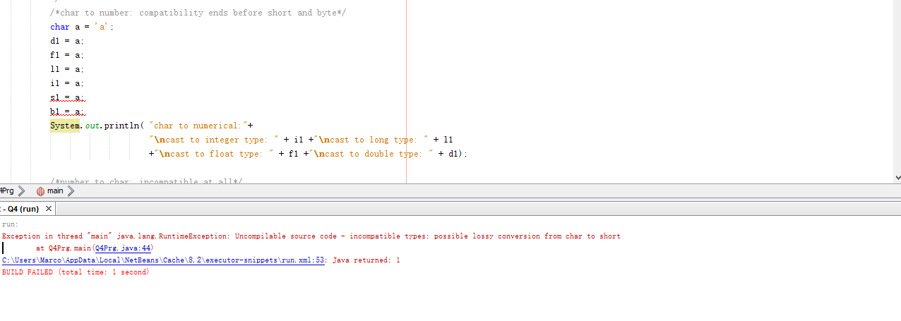

Num to char:

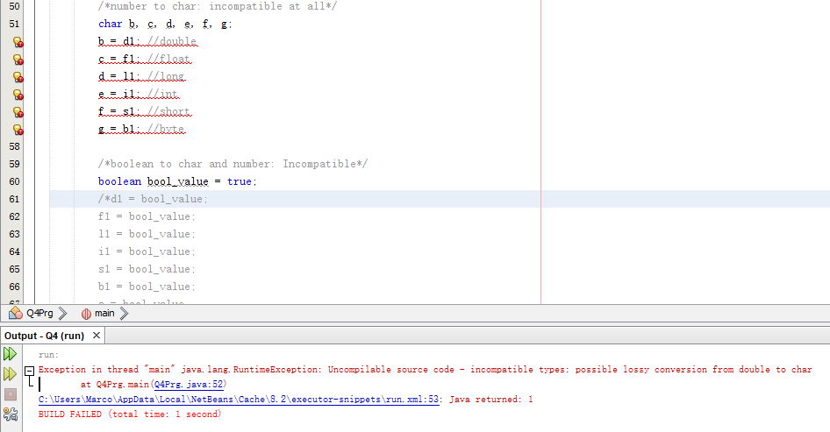

Char or num to bool:

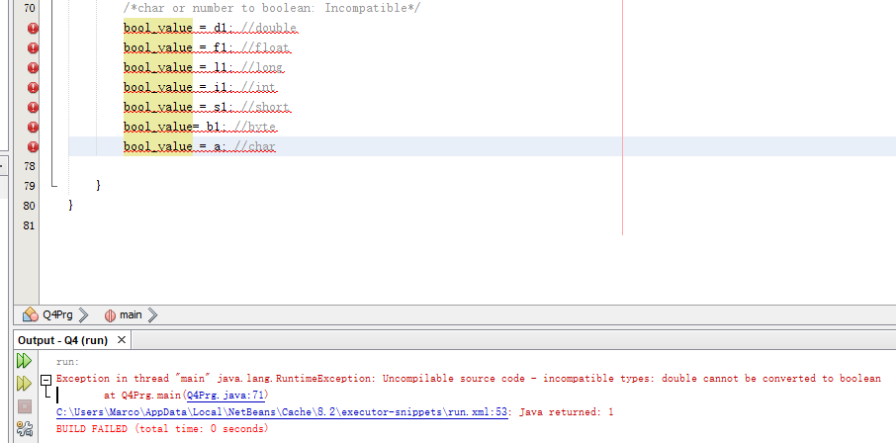

Bool to char or num:

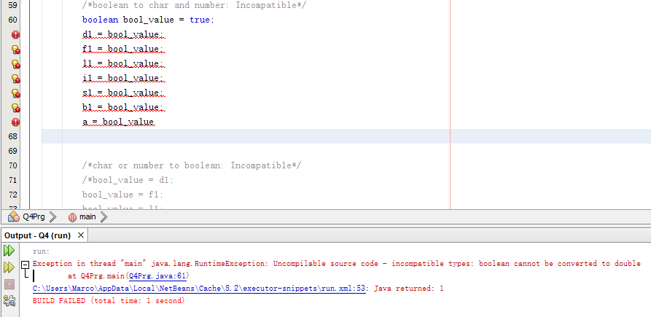

1. Write a simple program in C++ to investigate the safety of its enumeration types. Include at least 10 different operations on enumeration types to determine what incorrect or just silly things are legal

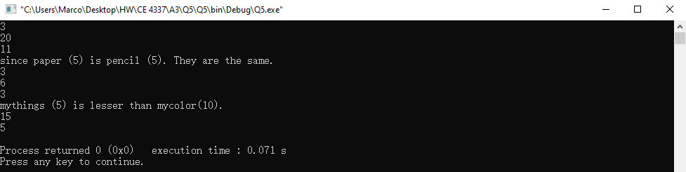

1. Write a C++ program that does a large number of references to elements of two-dimensioned arrays, using only subscripting. Write a second program that does the same operations but uses pointers and pointer arithmetic for the storage-mapping function to do the array references. Which of the two programs is likely to be more reliable? Why? (3- 6 lines)

Using subscripting is more reliable. Subscripting ties closely to the 2D array. As a result, it will not be destroyed until the end of execution. Subscripting also automatically calculates the correct address of each slot in the 2D array, avoiding the problem of mis-referencing. Using pointers not only goes over boundaries of each slot of the array easily, but also goes out of bound of the array easily (referencing something not allocated), making the probability of dangling pointer higher.

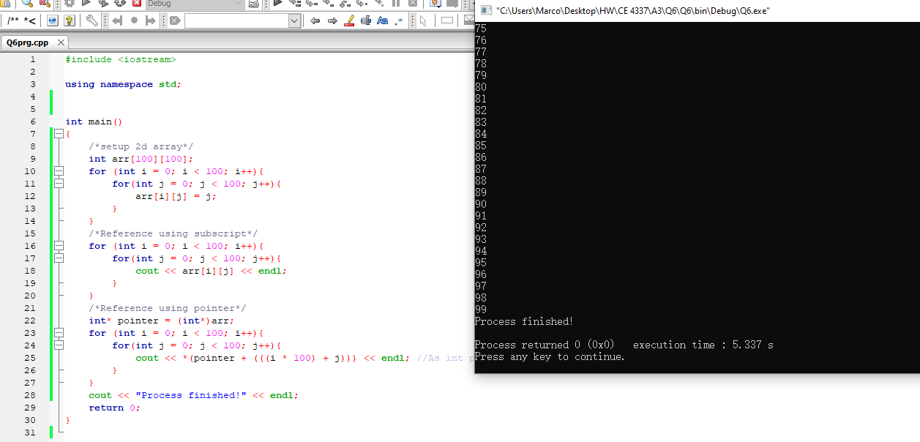

1. Write a Java program that exposes Java’s rule for operand evaluation order when one of the operands is a method call. Write a report (5 to 10 lines)

The lowest priority is the assignment symbol. The next symbol in the order of low to high is logical OR, then logical AND, then logical equality and logical inequality, then logical greater than along with logical less than, then addition and subtraction, including string concatenation, then multiplication, division and mods, then unary plus and minus, unary logical not, pre-increment and decrement, then post increment and decrement. The second highest priority will be a method call.

The highest priority in the operand is parentheses, associating from left to right.

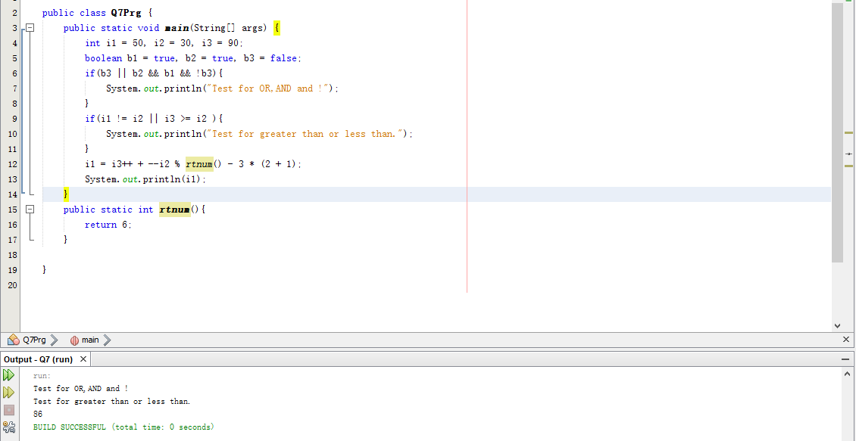

1. Answer the following Python Interview questions

* How is Python an interpreted language?
  + Because Python is not in machi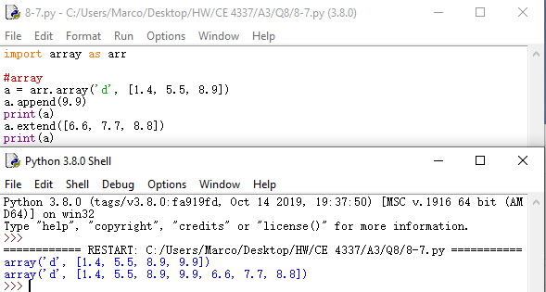ne code prior to runtime. Its translation happens as the program is executing. Its program runs directly from the source code.
* What is the difference between Python Arrays, lists, tuples, and records? Explain it with examples
  + Python array is a contiguous allocation for storing same type data
  + Python lists is a collection of data with no restriction of data type
  + Python tuple is an immutable list of unnamed data accessed through offsets from the beginning of the structure. 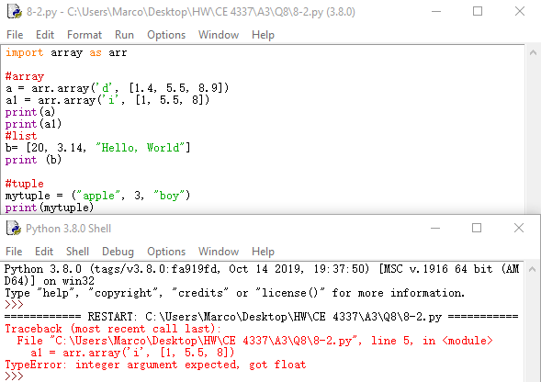

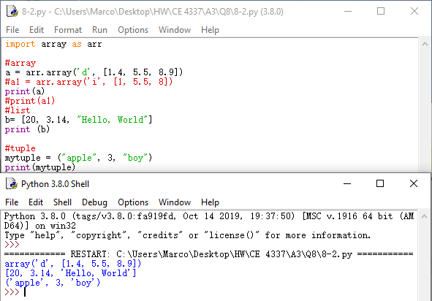

* + Python record is an aggregate of data elements in which the individual elements are identified by names and accessed through offsets from the beginning of the structure.

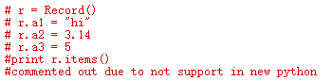

* What does [::-1} do? Explain it with an example
  + It reverse the order of the specified string.
  + 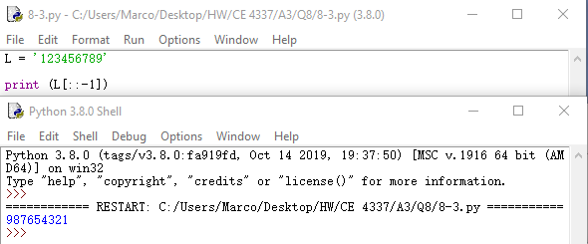
* How can you randomize the items of a list in place in Python?
  + First import random, then use command random.shuffle(List)
* What is the difference between range & xrange? Explain it with an example
  + They both generate a list of integers, but range outputs python list object, but xrange returns xrange object that generate its own integer object as the user access it. Xrange use less memory.
  + range generates a static list that is ready to use in memory when accessing. xrange has to generate an integer object every time when accessing an index.

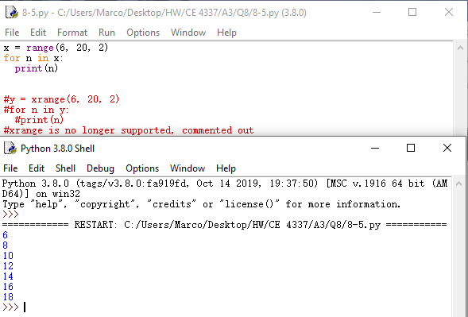

* What advantages do NumPy arrays offer over (nested) Python lists?
  + NumPy runs faster than nested list and permit efficient manipulation of homogeneous numerical data in Python.
  + Its speed boost makes manipulation of elements in multi-dimensional data more convenient.
* How to add values to a python array? Explain it with an example
  + To add a value to the end, use arr_name.append(value)
  + To add multiple values to the end use arr_name.extend([v1,v2,v3])



* What is split used for? Explain it with an example
  + When there is a string, str_name.split(‘symbol’) splits the string and gives every element separated by the symbol a slot in the new list.
  + Using str_name.split(‘symbol’, n-1) controls there are only n elements in the list. If n is smaller than the element separable, then the remainder of the list is put as the last element.

